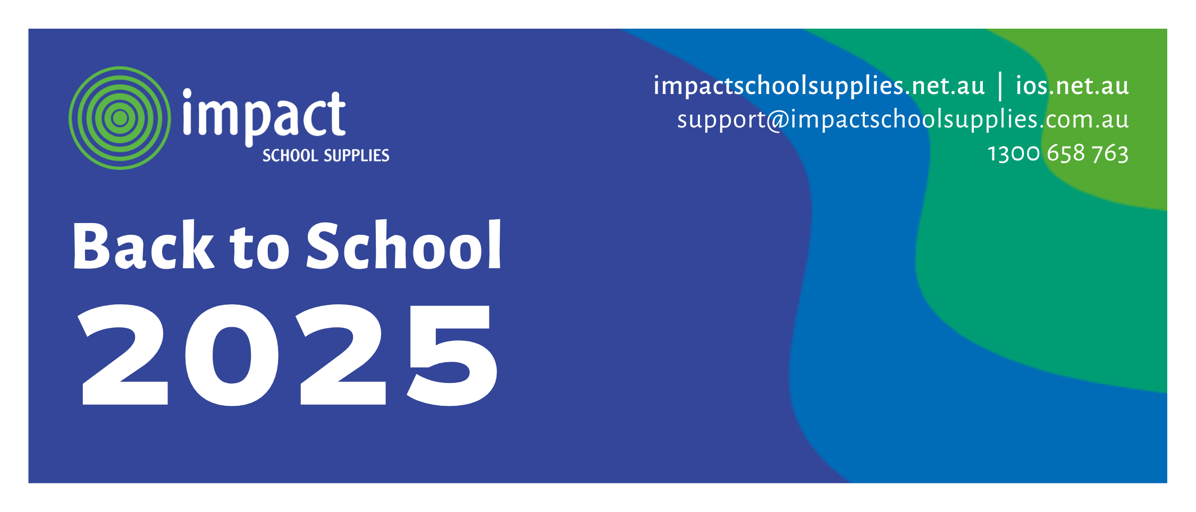

Dear Parents / Guardians and Students,

**Order your 2025 Back to School pack with Impact School Supplies!**

We are excited to announce that we have partnered with [**Impact School Supplies**](https://www.impactschoolsupplies.com.au/) as our Back-to-School provider for 2025. Proudly Queensland owned and operated, Impact School Supplies offers a wide range of **high-quality, branded school supplies**, outstanding customer service, and fast, reliable delivery by its own fleet and drivers. Our school has carefully selected the **best value products** to last your child the entire school year.

**Impact School Supplies offers parents:**

|  |  |  |  |
| --- | --- | --- | --- |
| **Competitive pricing** on high-quality school supplies. | Free delivery to your **home or office** during business hours. No PO boxes. | Flexible delivery dates **if you’re going away** - order early to secure your spot. | **One handling fee** when ordering multiple year packs. |

**Order Early for Reduced Handling and Guaranteed Delivery Dates:**

Order by 29th November 2024, P&H @ $3.95, delivery by 31st December 2024.

Order by 31st December 2024, P&H @ $7.95, delivery by 17th January 2025.

Order by 17th January 2025, P&H @ $16.95, delivery by 31st January 2025.

Orders after 17th January 2025, P&H @ $25.00, no guarantee of delivery before school starts.

**Going away?** [**Order now**](https://www.impactschoolsupplies.com.au/) **and select a delivery date that suits you at checkout!**

**Quick and Easy Ordering Process:**

1. Go to <https://www.impactschoolsupplies.com.au> and click **Parents Order Here**.
2. Enter the code: BASS6654 and click **login**.
3. Enter your email address, your child’s first and last name, and year level, then click **next**.
4. View your child’s book list and **order the required items**.
5. **Review your order**, check delivery details (no PO boxes), and total amount.
6. Proceed to the secure payment page to enter your credit card details and **complete your order**.

**Need a Helping Hand?**

Give Impact a call on **07 3153 4555** for all queries regarding book packs.

Send an online enquiry by visiting <https://www.impactschoolsupplies.com.au/contact>.

Get support via email at [support@impactschoolsupplies.com.au](mailto:support@impactschoolsupplies.com.au).